SUDEP Communication in Pediatric Epilepsy Care: A National Survey of Clinician Practices and Barriers in Canada
We invite Canadian clinicians involved in the care of children with epilepsy to participate in an anonymous, 5–10-minute online survey.
Scan the QR code to participate in our study: 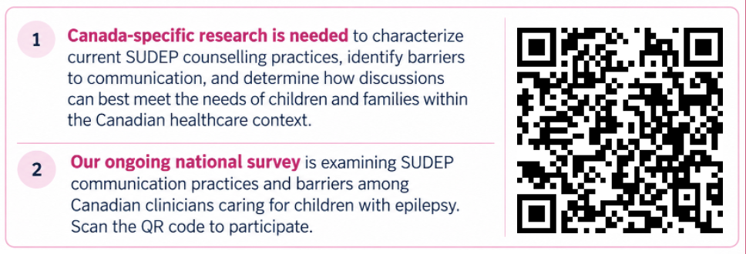
Participation is voluntary. The survey begins with a study information and consent form.
Principal Investigator: Dr. Anita N. Datta, University of British Columbia
UBC Research Ethics Board: H26-01513

